**Project Design Phase-II**

**Technology Architecture**

|  |  |
| --- | --- |
| Date | 24 October 2022 |
| Team ID | PNT2022TMID51364 |
| Project Name | Car Resale Value Prediction |
| Maximum Marks | 4 Marks |

**Technical Architecture:**

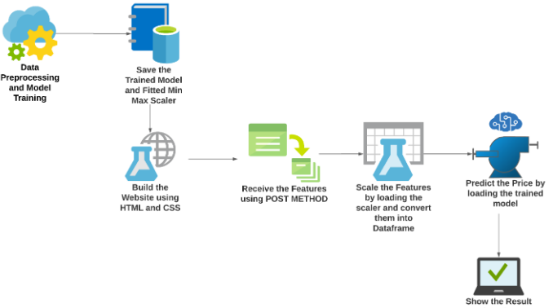

**Table-1 : Components & Technologies:**

|  |  |  |  |
| --- | --- | --- | --- |
| **S.No** | **Component** | **Description** | **Technology** |
| 1. | User Interface | How user interacts with application e.g. Web UI | HTML ,CSS etc |
| 2. | Application Logic-1 | Logic for a process in the application | Python |
| 3. | Application Logic-2 | Logic for a process in the application | IBM Watson STT service |
| 4. | Application Logic-3 | Logic for a process in the application | IBM Watson Assistant |
| 5. | Database | Data Type | MySQL |
| 6. | Cloud Database | Database Service on Cloud | IBM DB2, IBM Cloud etc. |
| 7. | File Storage | File storage requirements | IBM Block Storage |
| 8. | External API-1 | Purpose of External API used in the application | AADHAAR API |
| 9. | Machine Learning Model | Purpose of Machine Learning Model | Random forest algorithm etc. |
| 10. | Infrastructure (Server / Cloud) | Application Deployment on Local System / Cloud Local Server Configuration:  Cloud Server Configuration : | Local, IBM cloud |

**Table-2: Application Characteristics:**

|  |  |  |  |
| --- | --- | --- | --- |
| **S.No** | **Characteristics** | **Description** | **Technology** |
| 1. | Open-Source Frameworks | List the open-source frameworks used | Python Flask |
| 2. | Security Implementations | List all the security / access controls implemented, use of firewalls etc. | Encryptions, IAM Controls, OWASP |
| 3. | Scalable Architecture | Justify the scalability of architecture (3 – tier, Micro- services) | IBM cloud |
| 4. | Availability | Justify the availability of application (e.g. use of load balancers, distributed servers etc.) | IBM cloud |
| 5. | Performance | Design consideration for the performance of the application (number of requests per sec, use of Cache, use of CDN’s) etc. | IBM cloud |